Physics 30 Lesson 26 Cathode Rays

John Dalton, and many others, proposed that matter was composed of **indivisible** atoms. In the second half of the 19th century, experiments indicated that the atom was divisible and that atoms were composed of smaller **subatomic** particles.

# Cathode ray tube research

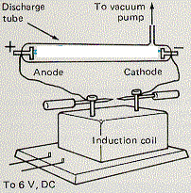

Many people experimented with various gas-discharge tubes which were attached to high voltage induction coils. A major difficulty was that air in the tubes effectively stopped particles from reaching the anode from the cathode. When the technology had improved to the point where most of the air could be evacuated from the tube, they discovered some interesting things. Eugene Goldstein conducted a series of experiments on what was called the Geissler beam. He gave the name **cathode ray** to the beam because it originated at the cathode. He found that the cathode rays travelled through thin metal foils and travel much further through air than atoms. Thus, cathode rays were known to be very small in mass.

In another experiment, Goldstein placed a small amount of hydrogen in the tube. The cathode ray was still there, but Goldstein also found a bluish tinge around the back end of the cathode that was not present in the normal vacuum tube. Goldstein had found a particle that traveled **toward** the cathode. We will refer to this discovery later.

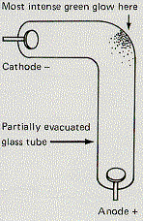

William Crookes did an experiment called the bent tube experiment. Crookes used a discharge tube similar to the one diagrammed and found that the cathode ray beam was most intense at the elbow of the tube . This experiment confirmed that cathode rays **traveled in straight lines**. Crookes also found that when a magnet was introduced near the beam of cathode rays, they bent in a direction that indicated they were **negatively charged particles**.

# The Thomson experiment

[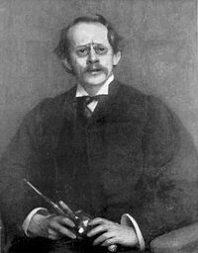](http://en.wikipedia.org/wiki/Image:Jj-thomson3.jpg)Sir Joseph John Thomson (1856 - 1940) attended Owen’s College in Manchester England and then went on to Cambridge University. He eventually became the head of the Cavendish Laboratories at Cambridge University. In 1897, Thomson conducted a series of experiments that would make him famous. He designed a special cathode ray tube that allowed the beam to be exposed to magnetic and/or electric fields. (Note that the following discussion of Thomson’s experiment is an application of the ideas that we learned in Lesson 20.) Refer to Pearson pages 754 to 758.

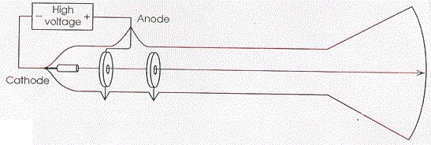The apparatus involved a vacuum tube with a high voltage induction coil. The anode ring had a hole in it to allow the high speed cathode rays through. A phosphor coating was painted on the end of the tube that glows when struck by cathode rays. The path of the cathode rays is straight and horizontal, which indicates that gravity has very little effect. Therefore the cathode rays must have a very small mass.

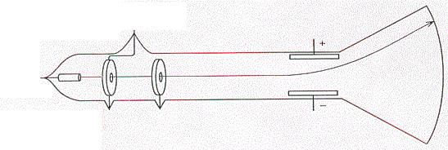Thomson installed a set of parallel plates attached to a variable voltage supply. When exposed to an **electric field** the cathode ray is bent upward due to the attractive pull of the positive plate and the repulsive push from the negative plate (i.e. cathode rays have a **negative** charge).

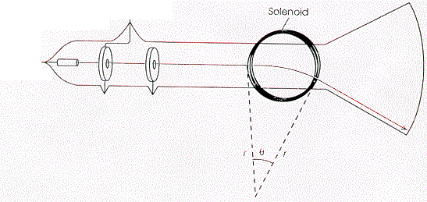Thomson then installed solenoids of wire (Helmholtz coils) that produced a uniform **magnetic field** through the tube (into the page). The cathode rays bent downward. By measuring the angle of deflection, he could measure the radius of curvature (r) through the magnetic field.

R

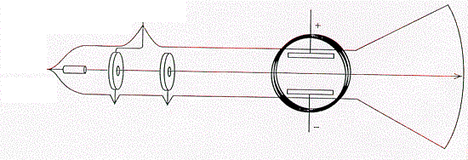In addition, when Thomson applied both an electric field and a magnetic field at the same time, the upward electric force could be set to balance the downward magnetic force resulting in a straight, horizontal path. He could then determine the speed of the cathode rays.



Once Thomson had determined the speed, he turned off the electric field and measured the radius of curvature for the cathode rays through the magnetic field. At the time (1897) Thomson did not know the mass nor the charge of the cathode rays. The only thing he could calculate was the **charge to mass ratio**. (It was not until Millikan’s measurement of the elementary charge in 1911 that the mass of an electron could be determined.)



A student performs a cathode ray tube experiment. The magnetic field strength from the coils was 0.040 T. The parallel plates were set 3.0 mm apart. In order to produce a straight cathode ray beam a 3600 V potential was applied across the plates. When the electric field is turned off, the cathode rays are bent into a curve of radius 4.26 mm by the magnetic field. What is the charge to mass ratio for the cathode ray particles?

First calculate the speed Second, calculate charge to mass ratio





Thomson tried different metals for the cathode, but he always found the same q/m ratio value of 1.76 x 1011 C/kg for all cathode ray particles. Therefore the same negative particle was always coming from the cathode. In 1891, George Johnston Stoney had proposed the term **electron** to describe the fundamental unit of electrical charge. Thomson renamed cathode rays electrons.

As stated above, Eugene Goldstein conducted a series of experiments with cathode ray tubes with a small amount of hydrogen gas in the tube. Thomson, who had already measured the charge to mass ratio for hydrogen ions, went on to study the particle produced by Goldstein in his Geissler tube.

In a modified Thomson experiment, when a hydrogen atom beam is exposed to a magnetic field of 0.0400 T and an electric field produced by 3600 V applied across parallel plates which are 3.00 mm apart, the particles go straight. When the electric field is turned off, the particles were observed to move through a radius of curvature of 7.828 m. What is the charge-to-mass ration for the hydrogen ions? (9.58 x 107 C/kg)

First calculate the speed Second, calculate charge to mass ratio





Thomson checked the charge to mass ratio for this positive particle and found it corresponded to the value for a hydrogen ion. Goldstein had discovered the **proton**.

Further tests revealed that the cathode ray particles neutralized the hydrogen ions on a one to one basis. In other words, electrons and protons had the same quantity of charge, but one was negative and the other positive. From the difference in their charge to mass ratios, Thomson concluded that a proton was more than 1700 times more massive than an electron. The currently accepted value is that a proton is 1836 times more massive than an electron.

J. J. Thomson had discovered particles that were smaller than anything Dalton had imagined. Thomson discovered the electron. Goldstein discovered the proton. Thomson’s work would lead us into the world of **subatomic physics**. The subatomic electrons and protons were present in all materials and are the basic building blocks for all atoms. In 1932 James Chadwick would confirm the existence of the **neutron** which is the third basic building block.

# The value of the elementary charge

As you recall from Lesson 17, R. A. Millikan conducted a series of experiments known as the **oil drop experiments** in 1909. His work, combined with J. J. Thomson’s work, would give a great deal of knowledge concerning the electron. In Millikan’s apparatus, a negatively charged oil drop is introduced between two charged plates. The electric field was manipulated in such a way as to freeze individual oil drops so that the force of gravity downward would be matched by the electric upward force.

An oil drop with a mass of 8.0 x 10-15 kg is introduced between two parallel plates set 5.0 mm apart with a potential difference of 1.225 kV across the plates. If the oil drop is suspended between the plates, what is the charge on the oil drop?



+ + + + + + + + + +

- - - - - - - - - - - - -

•



Millikan did several hundred runs of this experiment and he found results of 3.20 x 10-19 C, 9.60 x 10-19 C, 4.80 x 10-19 C, 1.60 x 10-19 C, 8.00 x 10-19 C and 6.40 x 10-19 C. Millikan quickly determined that all his values were multiples of **1.60 x 10-19 C**. Millikan had discovered the smallest possible unit of charge – the **elementary charge**.

The value he discovered was the charge of the electron, and the charge on an oil droplet was always an integer number multiple of the elementary charge.

Combining Millikan’s work with J.J. Thomson’s work, we can finally determine the mass of the electron and the proton:

 

The proton is 1836 times more massive than the electron, but its charge is equal in magnitude to that of the electron.

# Practice problems

1. In an experiment similar to Thomson's, cathode-ray particles were observed to move through a radius of curvature of 0.114 m when the magnetic field of 1.01 x 10-3 T acted alone. However, when the deflecting plates were properly adjusted, the rays were observed to travel straight through. If the plates were 1.00 cm apart and the potential difference across them was 200 V, calculate the charge to mass ratio. (1.72 x 1011 C/kg)

# Hand-in assignment

1. Derive the expression for the speed of a cathode ray particle passing straight through a magnetic field and an electric field.

2. Derive the expression to find the charge to mass ratio of a cathode ray particle.

3. In Thomson’s experiment on cathode rays, the speed of the cathode ray particles was found to be 4.0 x 107 m/s in a 1.0 x 10-4 T magnetic field. The corresponding electric field was provided by a charged parallel plate capacitor that had a separation of 2.0 cm. What was the potential difference across the plates? (80 V)

4. If J.J. Thomson had used *alpha particles* traveling at 5.0 x 107 m/s through a magnetic field of 2.0 T, what would the radius of deflection be? (0.52 m)

5. If the charge to mass ratio of a particle is 1.5 x 105 C/kg and the mass is

2.0 x 10-15 kg, what is the charge of the particle? (3.0 x 10-10 C)

6. A proton travels through a magnetic field at a speed of 5.60 x 105 m/s perpendicular to the field. If the radius of the arc of the deflected proton is 7.50 mm, what is the magnetic field strength? (0.779 T)

7. Alpha particles travel undeflected through magnetic and electric fields that are perpendicular to each another. The speed of the alpha particles is 7.50 x 105 m/s and the strength of the magnetic field is 0.220 T. What is the electric field strength? (1.65 x 105 V/m)

8. Alpha particles travel through a magnetic field of 0.360 T and are deflected in an arc with a radius of 8.20 cm. What is the energy of each alpha particle?

(6.71 x 10-15 J)

9. In a cathode ray tube an electron reaches a maximum speed of 4.75 x 107 m/s. If the electron accelerated from rest, what is the potential difference across the tube? (6.42 kV)

10. In a cathode ray tube electrons are accelerated from rest by a potential difference of 1.40 kV. If these electrons enter a magnetic field with a strength of 0.0220 T, what is the radius of arc for the deflected electrons? (5.74 mm)

11. A charged particle with a mass of 40 g is suspended in a Millikan oil drop apparatus that has a separation of 4.0 cm between the charged plates. If the potential difference required for the suspension is 1.633 x 1016 V, what is the number of excess electrons on the mass? (6)

12. In a Millikan oil drop experiment, five electrons are attached to a drop. The oil drop is placed into an electric field created by parallel plates which are 3.0 cm apart. If the mass of the oil drop is 3.0 pg, what potential difference is required to cause the oil drop to accelerate upwards at 3.0 m/s2? (1.4 x 103 V)

*13. **The search for anti-matter.**

At the beginning of time, 13.7 billion years ago, it is believed that an extremely dense ball of energy, small than an atom, exploded and sent high energy cosmic particles flying out in all directions. These particles were the origins of what is now known as the UNIVERSE. It is believed that at the time of the Big Bang, both matter and antimatter particles were created in equal numbers.

Anti-matter particles are identical to matter particles except that they carry the opposite charge to matter particles; for example, an electron which has a negative charge has an antimatter counterpart called a positron which has a positive charge. When matter meets antimatter they combine to form pure energy, and the matter component disappears. The fact that there is a lot of matter around and no antimatter has led some scientists to believe that there must be whole solar systems that are solely comprised of anti-matter.

Three American scientists (Ting, Ahlem, and Salamon) have proposed an experiment to be mounted on the International Space Station, Alpha. The experimental apparatus would look for evidence of antimatter and thus confirm the existence of anti-matter solar systems if such exists.

The experimental apparatus would consist of a large tubular magnet and detectors. When charged particles entered the tubular magnet they would be deflected by the magnetic field. The direction and the degree of deflection of the particle in the field would tell the scientist the charge and mass of the particle.

Cosmic particles are often composed of only the nucleus of the atom with no electron cloud. As a result the particle is ionized with a charge equal to the value of the number of protons in the nucleus. A helium atom, for example, has a charge of +2, has two protons and two neutrons, and is called an alpha particle. If it is anti-matter it has two antiprotons and two antineutrons and thus has a charge of -2.

Assume a particle enters the magnetic tube and is deflected as indicated below. The strength of the magnetic field is 1.00 x 10-3 T and it takes 4.175 ns for the particle to pass through the field. Is the particle matter or antimatter and what is the name of the particle? It could be any particle from atomic number 10 down to and including an electron or positron.

